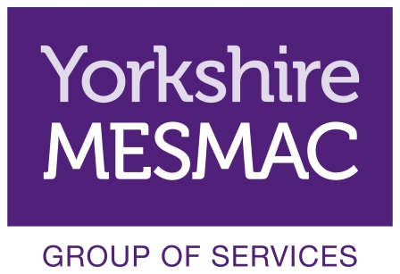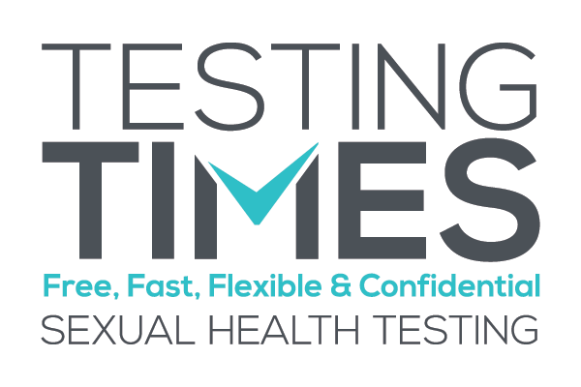
Volunteer Role Description
Community Testing Volunteer
Background Information
Community testing is carried out in Leeds city centre by Yorkshire MESMAC under the project name Testing Times. The service is an award winning high profile service within Yorkshire MESMAC and we are looking for keen and confident people who are interested in getting experience in outreach and health care.
The community testing bring rapid HIV testing and screening for urethral chlamydia and gonorrhoea to men who have sex with men away from a clinic setting.
Community testing currently take place every Tuesday and Thursday evening between 6pm and 8pm and the first Saturday of the month 12-3pm.
Community Testing Volunteers support the work of the testing carried out by Yorkshire MESMAC workers. This is done in a number of ways, from staff reception to undertaking outreach to the commercial Gay scene and other areas/events where our target groups meet/ socialise.
Community Testing Volunteers Core Roles
The core role of Community Testing Volunteers include:
• Providing service users and potential service users with information about community testing
• Explain to service users and potential service users STI transmission, treatment and prevention
• Giving out information to service users and potential service users
• Answering questions service users and potential service users may have about their sexual health
• Referring individuals to other Yorkshire MESMAC services or other groups / organisations
• Completing the necessary monitoring information as required
Other Opportunities for Development
Community Testing Volunteers are able to develop their own roles within the wider Yorkshire MESMAC volunteer group and these are as varied as the individuals who volunteer with Yorkshire MESMAC and have included in the past:
• Data entry
• Researching available support groups
• Website design
• Acting as a Trustee for Yorkshire MESMAC
• Training and Mentoring
Qualities, Skills and Experience of Community Testing Volunteers
No previous experience is required. However, it is essential that volunteers have:
• Good timekeeping
• Good listening skills
• Able to work with other people
• Able to use initiative
• A commitment to equal opportunities and anti-oppressive practice
• The ability to maintain appropriate boundaries
• A commitment to and the ability to maintain service and service user confidentiality in line with approved policy.
Full training is provided and you will attend training days. Once this is completed successfully you will remain with a ‘supervisor’ who is an experienced worker to ensure your safety and to comply with Yorkshire MESMAC safety policies.
Training, Induction & Supervision
Induction of Community Testing Volunteers has two stages these are typically:
1. Induction – A one day introduction to Yorkshire MESMAC and volunteering with Yorkshire MESMAC. The second session will look more specifically at community testing and HIV.
2. Supported Working – volunteers will always work with an existing worker. All work carried out as a volunteer with the Yorkshire MESMAC group of services will be in line with Yorkshire MESMAC health and safety policies.
Yorkshire MESMAC will allocate a suitably trained person to carry out supervision of Community Testing Volunteers. This will be in addition to pre and post session briefings and debriefs facilitated by the session lead worker. A bi-monthly group meeting will also be held to provide peer supervision.
Yorkshire MESMAC offers a wide range of training for all volunteers and all volunteers are expect to attend to attend at least 2 training sessions within the first year of volunteering. Training sessions particularly relevant to the Community Testing Volunteers include:
Listening Skills
Safer Sex and STIs
Working with Vulnerable People
Coming Out – Disclosure of Sexuality
All Community Testing Volunteers are encouraged to attend training sessions throughout their time as a volunteer.
Availability
• Community Testing currently takes place every Tuesday and Thursday evening between 6pm and 8pm and the first Saturday of the month between 12-3pm.
• Each Tuesday and Thursday shift starts at 5.45pm and ends at 8.00pm and each Saturday shift starts at 11.45 and ends at 3.00pm. Occasionally due to numbers of people being tested it may have a delayed finish however the volunteer will still be able to leave at 8.00pm
• You should arrive promptly for your shift and notify the Leeds office as soon as possible if you are unable to work a shift you have signed up for.
• We ask each Community Testing Volunteer to volunteer for at least one shift per month.
Location
Community Testing Support takes place across Leeds city centre including licensed premises, all volunteers will be working across the commercial Gay scene venues other areas event where LGBT+Q communities meet and socialise.

