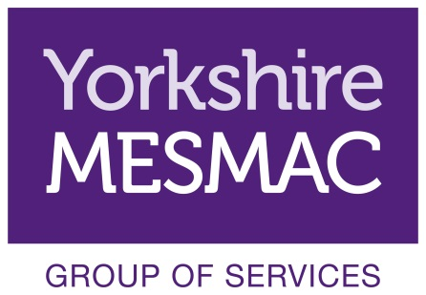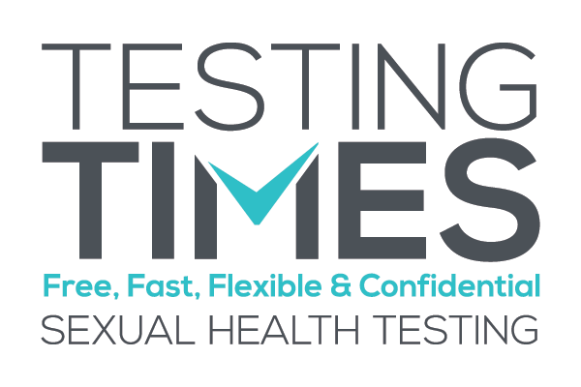

Volunteer Role Description

Community Testing Outreach Volunteers

Background Information
Community testing is carried out in Hull by Yorkshire MESMAC under the project name Testing Times. The service is an award winning high profile service within Yorkshire MESMAC and we are looking for keen and confident people who are interested in getting experience in outreach and health care.

The community testing service brings rapid HIV testing and screening for urethral chlamydia and gonorrhoea away from a clinic setting.
Community Testing Volunteers support the work of the testing carried out by Yorkshire MESMAC workers. This is done in a number of ways, from staff reception to undertaking outreach in targeted community groups.
Community Testing Volunteers Core Roles
The core role of Community Testing Volunteers include:
- Providing service users and potential service users with information about community testing
- Explain to service users and potential service users STI transmission, treatment and prevention
- Giving out information to service users and potential service users
- Answering questions service users and potential service users may have about their sexual health
- Referring individuals to other Yorkshire MESMAC services or other groups / organisations
- Completing the necessary monitoring information as required
Opportunities for Development
Community Testing Volunteers are able to develop their own roles within the wider Yorkshire MESMAC volunteer group and these are as varied as the individuals who volunteer with Yorkshire MESMAC and have included in the past:
- Data entry
- Researching available support groups
- Website design
- Acting as a Trustee for Yorkshire MESMAC
- Training and Mentoring
Qualities, Skills and Experience of Community Testing Volunteers
No previous experience is required. However, it is essential that volunteers have:
- Good timekeeping
- Good listening skills
- Able to work with other people
- Able to use initiative
- A commitment to equal opportunities and anti-oppressive practice
- The ability to maintain appropriate boundaries
- A commitment to and the ability to maintain service and service user confidentiality in line with approved policy
Full training is provided. Once this is completed successfully you will remain with a ‘supervisor’ who is an experienced worker to ensure your safety and to comply with Yorkshire MESMAC safety policies.
Training, Induction & Supervision
Induction of Community Testing Volunteers has two stages these are typically:
- Induction – A one day introduction to Yorkshire MESMAC and volunteering with Testing Times
- Supported Working – volunteers will always work with an existing worker. All work carried out as a volunteer with the Yorkshire MESMAC group of services will be in line with Yorkshire MESMAC health and safety policies.
Yorkshire MESMAC will allocate a suitably trained person to carry out supervision of Community Testing Volunteers. This will be in addition to pre and post session briefings and debriefs facilitated by the session lead worker. A quarterly group meeting will also be held to provide peer supervision however supervision can take place at any time.
Yorkshire MESMAC offers a wide range of training for all volunteers and all volunteers will have the opportunity to access training on specialised subjects such as male child sex exploitation.
All Community Testing Volunteers are encouraged to attend training sessions through-out their time as a volunteer.
Availability
- Community Testing currently takes place in various locations both in our building and out in the community. Hours and shifts are varied.
- You should arrive promptly for your shift and notify the Hull office as soon as possible if you are unable to work a shift you have signed up for.
- We ask each Community Testing Volunteer to volunteer for at least one shift per month.
Location
Community Testing Support takes place across Hull including licensed premises and community groups.

