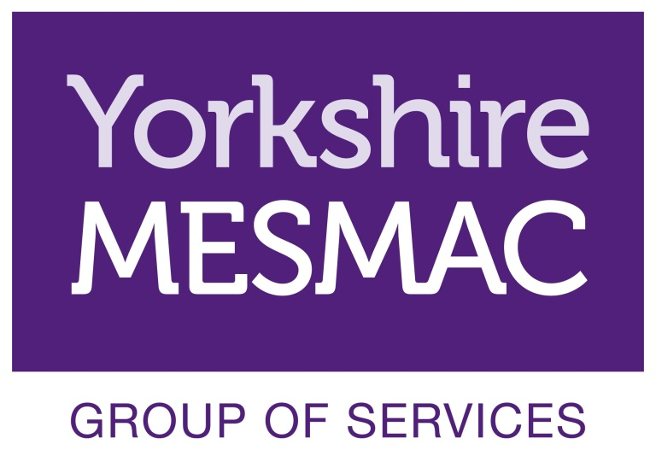
Volunteer Role Description
Community Education Volunteer

Background Information
Yorkshire MESMAC Hull started its delivery of sexual health services in the city in 2015 to help prevent the spread of STIs and reduce late diagnosis through testing, education and community action. Our main focus is on at-risk groups that include:
- Gay and bisexual men and men who have sex with men
- Women, families and women dating after divorce or separation
- Black and other ethnic minorities

One of cornerstones of our delivery is service user and stakeholder training and workshops.

Community Education Volunteer role
Community Education Volunteers work alongside an employed staff member to facilitate and support training groups and workshops:
- Helping to prepare the setting for sessions
- Helping to create a friendly, relaxed environment
- Promoting participation in activities
- Providing feedback, input and suggestions for future training and workshops
- Supporting the delivery team

Opportunities for Development
In addition to the work in community education, volunteers’ input is welcome in the following areas:
- Networking through their own contacts to publicise and recommend the community education activity
- Contributing to training delivery with ideas on how to develop the reach and relevance of the materials
- Devising new training, publicity and marketing materials
- Working with new groups as they develop

Qualities Skills and Experience of Community Education Volunteer
Community Education Volunteers will:
- Be reliable, flexible and trustworthy
- Offer empathy, respect and be genuinely interested in people
- Be good listeners
- Be non-judgemental and respectful of people’s opinions and decisions
- Have experience of or an interest in training

Training, Induction & Supervision
Induction of Community Education Volunteers has two stages these are typically:

- Induction – A one day introduction to Yorkshire MESMAC and volunteering with Yorkshire MESMAC Hull
- Supported Working – volunteers will always carry out activity with an existing worker. All activity carried out as a volunteer with the Yorkshire MESMAC group of services will be in line with Yorkshire MESMAC health and safety policies.
Yorkshire MESMAC will allocate a suitably trained person to carry out supervision of Community Education Volunteers. This will be in addition to pre and post session briefings and debriefs facilitated by the session lead worker.
Yorkshire MESMAC offers a wide range of training for all volunteers and all volunteers will have the opportunity to access training on specialised subjects such as male child sex exploitation.
All Community Education Volunteers are encouraged to attend training sessions through-out their time as a volunteer.

Availability and Location
Yorkshire MESMAC is happy to negotiate with volunteers as to when they will attend sessions to suit both their own personal circumstances and the training timetable.

Community education and training takes place at various times and locations to suit service users and stakeholders. Times and locations will be arranged to suit both the volunteer and the organisation.

