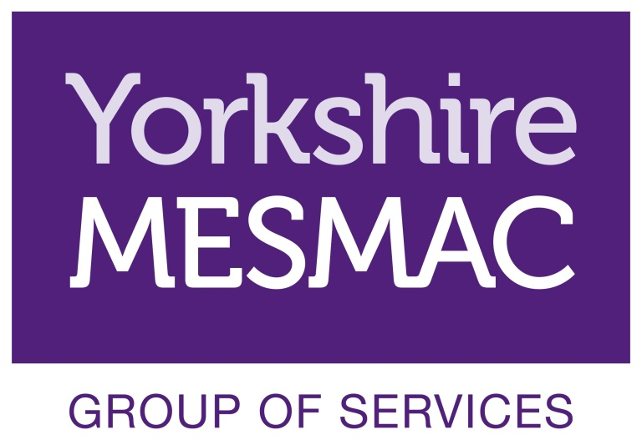
Volunteer Role Description
Young/Peer Educator Volunteer

Background Information

Yorkshire MESMAC is one of the oldest and largest sexual health organisations in the country.

We offer services to various communities including
- MSM (Men who have sex with men)
- BME (Black and minority ethnic) people
- People misusing drugs
- Sex workers
- LGB&T young people and adults

Young Educators is a year-long project focusing on identifying and training young MSM volunteers to become Peer Educators in HIV awareness. We are seeking to empower young MSM to be community leaders in sexual health education, delivering an accessible and appropriate training package within their own peer group trained and supported by a designated member of staff.

Young educators are empowered to help identify groups where they feel the training will be appropriate.

Upon completion of the initial training Young Educators will have the knowledge and skills to deliver the training package to their peers within the groups identified.

Peer Educator Volunteer role

Peer Educator Volunteers are trained by an employed staff member to facilitate training groups and workshops in HIV awareness.
- preparing the setting for sessions
- creating a friendly, relaxed environment
- Leading activities and promoting participation in activities
- Providing feedback, input and suggestions for future training and workshops
- Identify groups from within their own community to deliver training

Opportunities for Development

In addition to the work in Peer education, volunteers’ input is welcome in the following areas:
- Networking through their own contacts to publicise and recommend the peer education activities
- Contributing to training delivery
- Working with new groups as they develop

Qualities Skills and Experience of Community Education Volunteer

Community Education Volunteers will:
- Be reliable, flexible and trustworthy
- Offer empathy, respect and be genuinely interested in people
- Be good listeners
- Be non-judgemental and respectful of people’s opinions and decisions
- Have experience of or an interest in training

Training, Induction & Supervision

Induction of Peer Education Volunteers has two stages these are typically:

- Induction – A one day introduction to Yorkshire MESMAC and volunteering for the Young Educators Project
- Peer education – volunteers will carry out activities within group settings. All activity carried out as a volunteer with the Yorkshire MESMAC group of services will be in line with Yorkshire MESMAC health and safety policies.
Yorkshire MESMAC will allocate a suitably trained staff member to train the Peer Educators.
Volunteers will be supported to practice delivery of the sessions throughout their training.
Volunteers will give post session feedback to the project leader.
Yorkshire MESMAC offers a wide range of training for all volunteers and all volunteers will have the opportunity to access training on specialised subjects such as male child sex exploitation.

All Peer Education Volunteers are encouraged to attend training sessions through-out their time as a volunteer.

Availability and Location

Yorkshire MESMAC is happy to negotiate with volunteers as to when they will attend sessions to suit both their own personal circumstances and the training timetable.

Peer education and training takes place at various times and locations to suit service users and stakeholders. Times and locations will be arranged to suit both the volunteer and the organisation.

