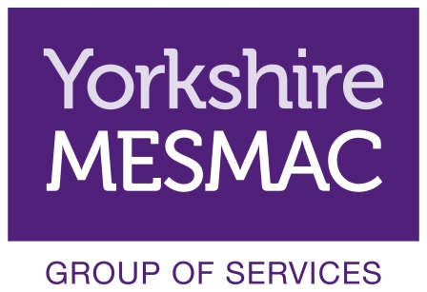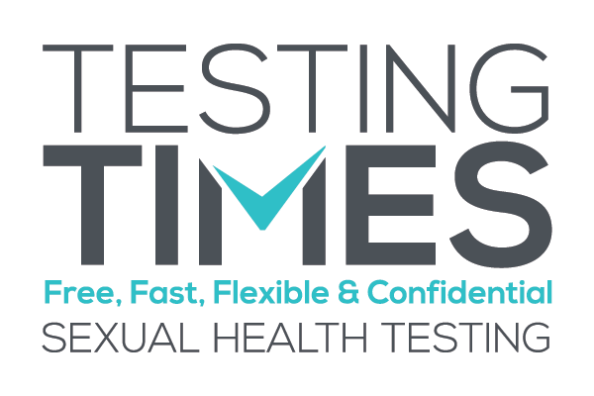
Volunteer Role Description
Community Testing Volunteers
About Yorkshire MESMAC Rotherham
Yorkshire MESMAC is one of the oldest and largest sexual health organisations in the country. Yorkshire MESMAC Rotherham is one of our services. Our focus is HIV prevention and sexual health promotion carried out through community development, education and advice.
Yorkshire MESMAC is a non-statutory organisation that is funded through a range of sources including service level agreements with Primary Care Trusts, Local Authorities and Charitable Trusts as well as community fundraising and individual donations.
Community testing takes place every Tuesday between 10am and 2pm, Wednesdays between 4pm and 7 pm, Thursday between 3pm and 7pm and the first Saturday of each month between 11am and 3pm.
About the opportunity
Community testing is carried out in Rotherham by Yorkshire MESMAC under the project name Testing Times. The service is an award winning high profile service within Yorkshire MESMAC and we are looking for keen and confident people who are interested in getting experience in outreach and health care.
The community testing service brings rapid HIV testing and screening for urethral chlamydia and gonorrhoea away from a clinic setting.
Community Testing Volunteers support the work of the testing carried out by Yorkshire MESMAC workers. This is done in a number of ways, from staff reception to undertaking outreach in targeted community groups.
Community Testing Volunteers Core Roles:
- Providing service users and potential service users with information about community testing
- Explaining to service users and potential service users STI transmission, treatment and prevention
- Giving out information to service users and potential service users
- Answering questions service users and potential service users may have about their sexual health
- Referring individuals to other Yorkshire MESMAC services or other groups / organisations
- Completing the necessary monitoring information as required
What are we looking for?
No previous experience is required. However, it is essential that volunteers have:
- Excellent timekeeping
- Excellent listening skills
- Able to work with other people
- Able to use initiative
- A commitment to equal opportunities and anti-oppressive practice
- The ability to maintain appropriate boundaries
- Yorkshire MESMAC is proud of offering a confidential service so it is very important that Staff and Volunteers adhere to our confidentiality policy
- A commitment to and the ability to maintain service and service user confidentiality in line with approved policy
Full training is provided and there will be introduction to Yorkshire MESMAC and volunteering, as well as community testing and HIV.
Induction, Training & Supervision
Induction of Community Testing Volunteers has two stages, these are typically:
- Induction – a one day introduction to Yorkshire MESMAC and volunteering with Yorkshire MESMAC. The second session will look more specifically at community testing and HIV.
- Supported Working – volunteers will always work with an existing worker. All work carried out as a volunteer with the Yorkshire MESMAC group of services will be in line with Yorkshire MESMAC health and safety policies.
Yorkshire MESMAC offers a wide range of training for all volunteers and all volunteers are expected to attend at least 2 training sessions within the first year of volunteering. Training sessions particularly relevant to the Community Testing Volunteers include:
- Listening Skills
- Safer Sex and STIs
- Working with Vulnerable People
- Coming Out – Disclosure of Sexuality
All Community Testing Volunteers are encouraged to attend training sessions throughout their time as a volunteer.
Yorkshire MESMAC will allocate a suitably trained person to carry out supervision of Community Testing Volunteers. This will be in addition to pre and post session briefings and debriefs facilitated by the session lead worker. A bi-monthly group meeting will also be held to provide peer supervision.
Practical Considerations
All volunteers are covered by insurance. Volunteers are given a full induction and training. Travel expenses are reimbursed. Volunteers should arrive promptly for their shift and notify the Rotherham office as soon as possible if they are unable to work a shift they have signed up for. We ask each Community Testing Volunteer to volunteer for at least one shift per month.
Location
Community Testing Support takes place across Rotherham area. All volunteers will be working across the community settings, such as colleges.

